How to configure the Docker in AWS Ubuntu Instance

* sudo apt-get install \

sudo apt-transport-https \

sudo ca-certificates \

sudo curl \

sudo software-properties-common

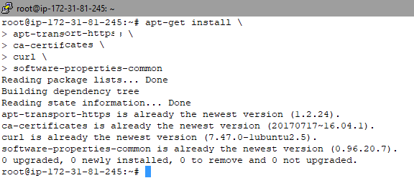

* curl -fsSL https://download.docker.com/linux/ubuntu/gpg | sudo apt-key add –



* sudo add-apt-repository \

"deb [arch=amd64] https://download.docker.com/linux/ubuntu \

$(lsb_release -cs) \

stable"



* sudo apt-get update
* sudo apt-get install docker-ce 🡪 here docker –ce means docker community edition
* docker --version 🡪 to now the version of the docker
* docker –v 🡪 to now the version of the docker

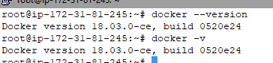

* how to login to docker hub to ubuntu

docker login

username:

password:

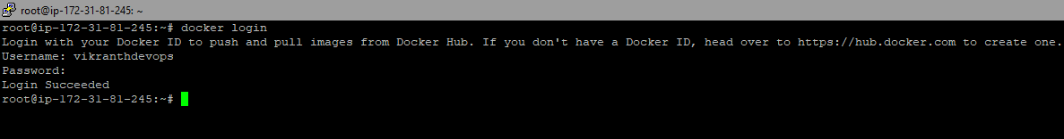

* How to download the image from docker hub to ubuntu

**docker run -it centos /bin/bash🡪 u will enter into the docker image**

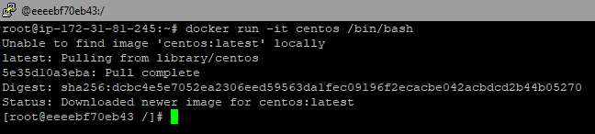

**Open duplicate session run this**

* **Docker run –it ubuntu /bin/bash**

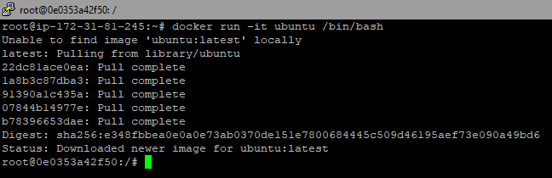

**How to display the all running container in docker**

**Docker ps**

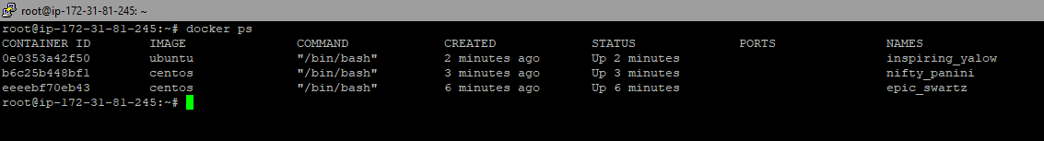

**How to display the all running and stopped container in docker**

**Docker ps –a**



**How to display the docker images**

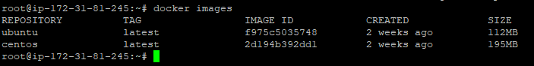

**How to create file from outside of the docker container**

**docker exec <cid> <touch file name>**

**docker exec fe3907a863c7 touch file**







**How to check the docker container ip address**

**docker inspect <Container ID>**

**docker inspect fe3907a863c7**

**hostname –i**

